**Practical Exercise - Walkthrough**

**Since this is a relatively simple automation, use the Excel Application Scope activity to execute the task of reading the workbook.**

* Create a blank sequence workflow
* Find and add an **Excel Application Scope**activity
* Use the browse function or manually fill in the workbook path parameter of the Excel file (downloaded from the Outline)
* Find and add an Excel Scope Compatible **Read Range**activity inside the ‘Do’ container of the **Excel Application Scope**
* In the output parameter, use the create variable command to create a DataTable called **wordDT**
* This is what the workflow should look like:

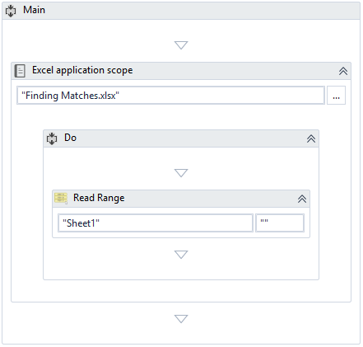

Next, the workflow needs to iterate through each row of the extracted DataTable and check if the columns are equal.

* Find and add a **For Each Row**activity below the **Read Range**activity

             o       It should loop through each row in **wordsDT**

* Find and add an **If** activity inside the body of the **For Each Row**

             o       Set the condition to check if the first column is equal to the second column

                      ▪        Type ‘row(0).ToString = row(1).ToString’

* Find and add an Assign activity and place it in the **Then**branch of the **If** activity

             o       Use the Ctrl + K (variable creation) shortcut to create a variable called rowIndex

             o       Assign count this expression: wordsDT.Rows.IndexOf(row) + 1

                      ▪        This evaluates to the index of the DataTable row - the + 1 at the end is to account for Excel sheets that start their index at 1 rather than 0

* Find and add a **Write Line**activity inside the **Then**branch of the **If** activity

             o       Set the text to write “Match in Row: ” + rowIndex.ToString

                      ▪        The .ToString converts the index to a string so it can be concatenated

* This is what the final workflow looks like:

